Multiplication Table of Prime Numbers

## **About the solution:**

- Please run the code at localhost. It prints a multiplication table of the first 10 prime numbers.

- We can change number of prime numbers and table gets printed accordingly.

- The program also runs from command line but and prints one table at UI/browser properly.

- Please refer screenshots of table of different length of prime numbers.

### Sample Screenshots:

**Fig: Default table with 10 prime numbers**

**Fig: Table with 5 prime numbers**

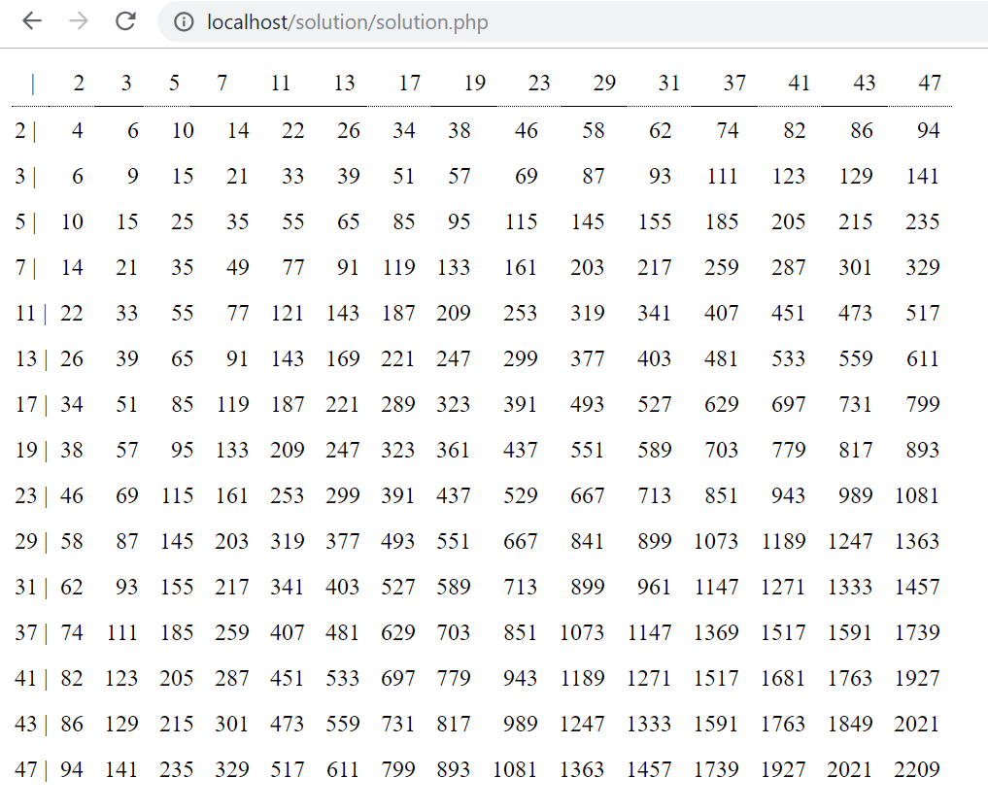

**Fig: Table with 15 prime numbers**

## **Instructions (as provided):**

**- Consider code readability/complexity**

-- Code is readable and simple

**- Consider cases where we want more than ‘10’ primes**

-- Considered. We can change number of primes.

**- Consider KISS and not over­engineering**

-- Implemented as suggested.

**- Consider re­usability**

-- Code is reusable as:

- Methods are small and have specific responsibilities.

- Developed in a way that it can be extended with little or no change required.

- Suggestions already provided to initialize number of primes needed.

- We can also print any table not just prime number table with a little change very easily.

**- Write your own implementation for generating prime numbers (DO NOT use a library)**

-- Implemented as suggested.

**- Write tests**

-- Faced issues while installing PHPUnit because of version mismatch.

-- Spent couple of hours but could not spend more time as it is a POC. To save time did not write tests but have written unit tests in other projects.

**- Write it in PHP**

-- Implemented as suggested.

**Thanks & Regards,**

Shashank Raj, [imshashankraj@yahoo.com](mailto:imshashankraj@yahoo.com), +91.9533740074

Ph